Exp. No: 9
ANALYSIS OF PHOTODETECTOR NOISE AND SNR USING MATLAB

OBJECTIVES
- Analyze the key noise sources in an optical photodetector, namely shot noise, dark current noise and thermal (receiver) noise.
- Compute the individual and total noise current variances (σ²) across a range of input optical powers.
- Evaluate the Signal-to-Noise Ratio (SNR) and observe its scaling in the thermalnoiselimited and shot-noise-limited regimes.
- Calculate the Minimum Detectable Optical Power (Pmin) at SNR = 1 (0 dB).
- Simulate and visualize photodetector noise and SNR curves using MATLAB.

SOFTWARE REQUIRED
• MATLAB software

MATLAB CODE

% Photodetector Noise and SNR Analysis
clc; clear; close all;
%% 1. Constants and input parameters q = 1.602e-19; % Electron charge (C) kB = 1.381e-23; % Boltzmann constant (J/K) h = 6.626e-34; % Planck's constant (J.s) c = 2.998e8; % Speed of light (m/s) lambda = 1550e-9; % Wavelength (m) eta = 0.85; % Quantum efficiency Id = 5e-9; % Dark current (A)
T = 300; % Temperature (K)
RL = 50; % Load resistance (ohm)
Fn = 2; % Noise figure (linear)
B = 1e9; % Bandwidth (Hz)
Pdbm = -60:0.1:0; % Input power (dBm)
P = 10.^((Pdbm - 30)/10); % Input power (W)
%% 2. Responsivity and signal current
R = eta*q*lambda/(h*c); % Responsivity (A/W)
Ip = R.*P; % Photocurrent (A) %% 3. Noise variances and SNR var_shot = 2*q.*Ip*B; % Shot noise variance (A^2) var_dark = 2*q*Id*B; % Dark current noise variance var_th = 4*kB*T*B*Fn/RL; % Thermal noise variance var_tot = var_shot + var_dark + var_th;
SNR = Ip.^2 ./ var_tot;
SNR_dB = 10*log10(SNR);
%% 4. Minimum detectable power (SNR = 1) % R^2*P^2 - 2*q*B*R*P - (var_dark + var_th) = 0 a = R^2; b = -2*q*B*R; cc = -(var_dark + var_th);
Pmin = (-b + sqrt(b^2 - 4*a*cc))/(2*a);
PmindBm = 10*log10(Pmin) + 30;
%% 5. Display calculated results [~,k] = min(abs(Pdbm - (-30))); fprintf('Responsivity R = %.4f A/W\n', R); fprintf('Thermal variance = %.3e A^2\n', var_th); fprintf('Dark variance = %.3e A^2\n', var_dark); fprintf('Shot variance (-30 dBm) = %.3e A^2\n', var_shot(k)); fprintf('SNR at -30 dBm = %.2f dB\n', SNR_dB(k)); fprintf('Pmin (SNR = 1) = %.2f dBm (%.1f nW)\n',PmindBm, Pmin*1e9);
%% 6. Test cases: -50 dBm, -30 dBm and 0 dBm Ptest_dBm = [-50, -30, 0]; fprintf('\n----- TEST CASE RESULTS -----\n'); for i = 1:length(Ptest_dBm)
Pin_dBm = Ptest_dBm(i);
Pin = 10^((Pin_dBm - 30)/10); Iptest = R*Pin; shot_test = 2*q*Iptest*B; total_test = shot_test + var_dark + var_th; SNR_test = Iptest^2/total_test; SNR_test_dB = 10*log10(SNR_test); fprintf('\nInput power = %.0f dBm\n', Pin_dBm); fprintf('Photocurrent = %.3e A\n', Iptest); fprintf('Shot variance = %.3e A^2\n', shot_test); fprintf('Thermal variance = %.3e A^2\n', var_th); fprintf('Total variance = %.3e A^2\n', total_test); fprintf('SNR = %.2f dB\n', SNR_test_dB); end %% 7. Plots figure; subplot(2,1,1); loglog(P, var_th*ones(size(P)), ...
P, var_dark*ones(size(P)), ...
P, var_shot, ...
P, var_tot, 'LineWidth', 1.2); grid on; xlabel('Input Power (W)'); ylabel('Noise Variance (A^2)'); title('Photodetector Noise Variance'); legend('Thermal Noise', 'Dark Noise', ... 'Shot Noise', 'Total Noise', 'Location', 'best'); subplot(2,1,2); plot(Pdbm, SNR_dB, 'b', 'LineWidth', 1.5); hold on; plot([-60 0], [0 0], 'r--', 'LineWidth', 1.2); plot([PmindBm PmindBm], [-60 70], 'k:', 'LineWidth', 1.2); grid on; xlabel('Input Power (dBm)'); ylabel('SNR (dB)'); title('Signal-to-Noise Ratio versus Input Power'); legend('SNR', 'SNR = 0 dB', ...
'Minimum Detectable Power', 'Location', 'best'); hold off;

OUTPUT GRAPH
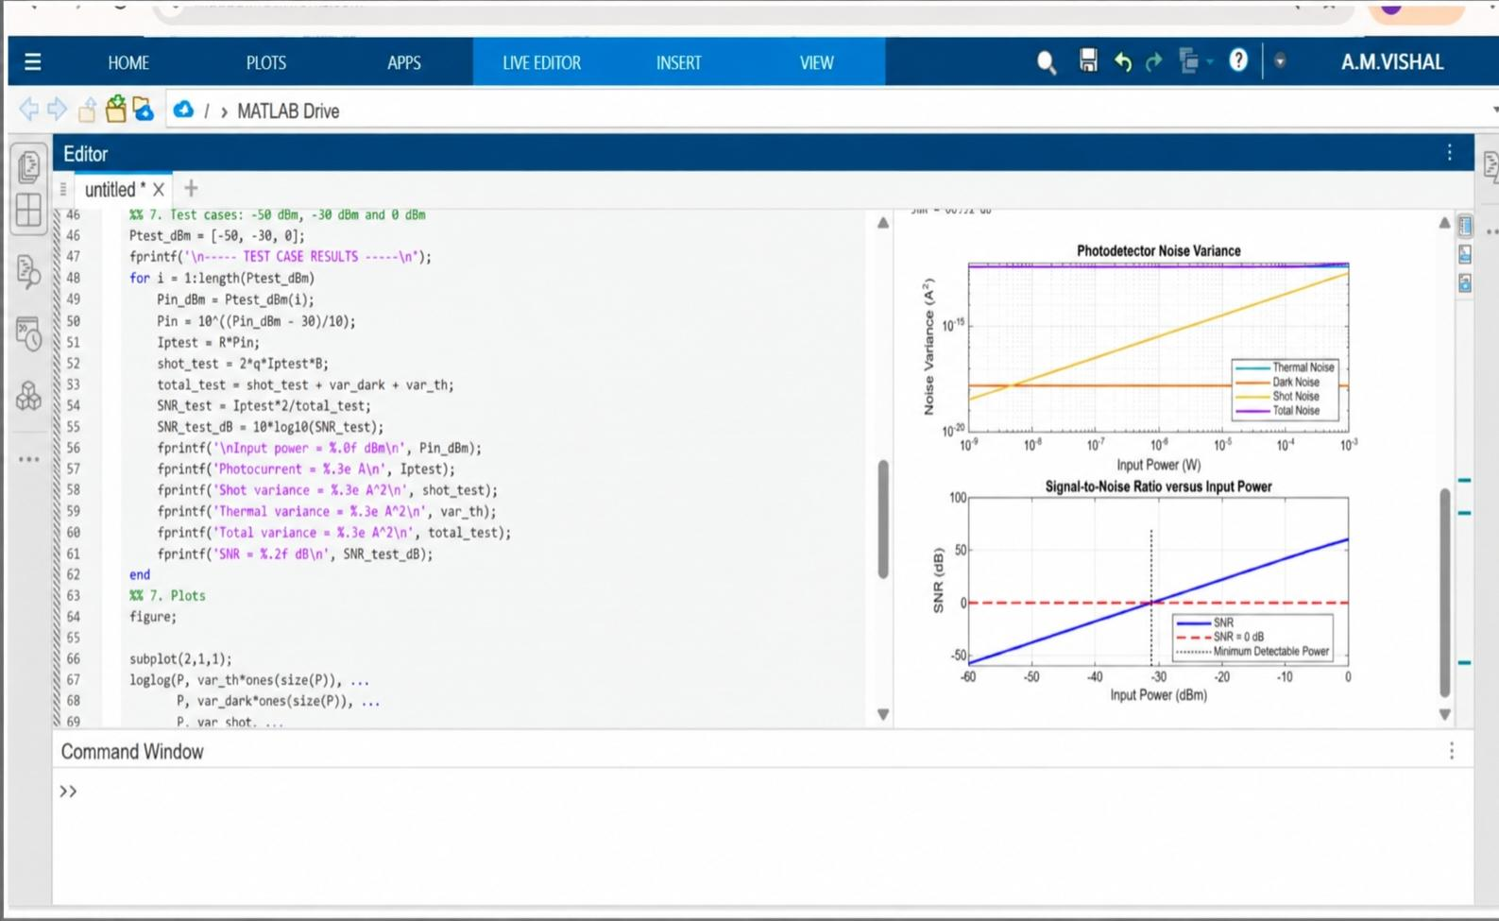

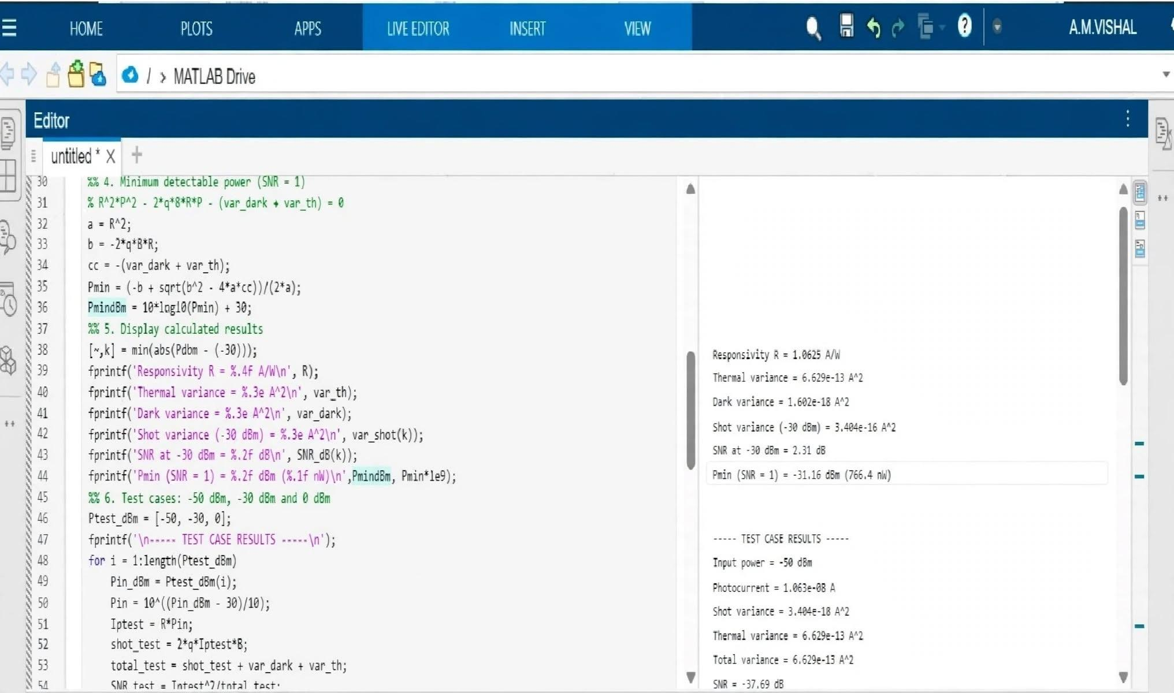

Reflection
I learned how thermal noise, dark current and shot noise affect receiver performance and how SNR changes with input optical power.

LABORATORY PERFORMANCE ASSESSMENT RUBRIC
Objective | Assessment  Criterion | Excellent – 4 |  | Good – 3 | Satisfactory – 2 | Needs Improvement – 1 | Weightage
Develop the MATLAB  program with correct constants and system parameters. | Program Setup and Parameter  Definition | Defines all constants and parameters correctly with proper units and a clean script structure, independently. | Defines parameters correctly with minor unit or syntax errors and limited assistance. | Defines most parameters but needs considerable assistance or has unit errors (e.g., dBm/W, linear Fn). |  |  |  | Unable to set up the script or define the parameters. | 25
Compute R, signal current, noise variances and SNR across the power sweep. | Simulation  Execution and  Data  Acquisition | Computes R, Ip, all noise variances and SNR correctly over −60 to 0 dBm and records the values. | Computes all quantities with minor errors or omissions. | Computes some quantities with noticeable errors or inconsistencies. |  |  |  | Unable to run the simulation or record the values. | 25
Obtain the noise and SNR plots and determine Pmin. | Graph Plotting and Pmin Determination | Plots accurate log– log and semi-log curves with labels and reference lines; Pmin within  5% of the reference. | Plots the curves with minor errors; Pmin identified with small deviation. | Plots partial or poorly scaled  curves; Pmin  approximate. |  |  |  | Unable to plot the curves or determine Pmin. | 25
Interpret noise regimes, SNR slopes and receiver sensitivity. | Analysis and  Engineering  Interpretation | Correctly identifies thermal- and shot-limited regimes, explains the SNR slopes and links results to receiver design. | Identifies the regimes with minor errors and reasonable interpretation. | Performs basic interpretation with noticeable errors or limited justification. |  |  |  | Unable to interpret the results. | 25

Result
Photodetector noise and signal-to-noise ratio were analyzed using MATLAB.

